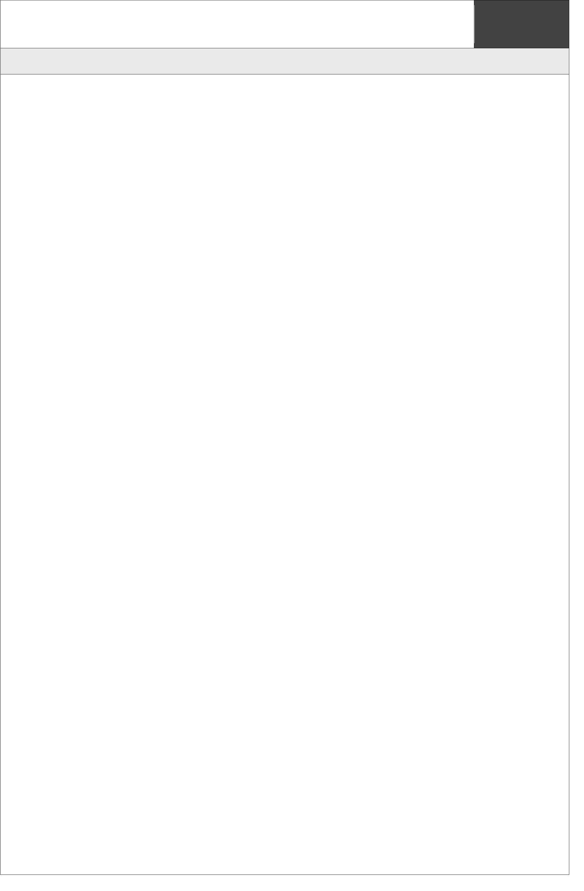

**PROJECT**

**PROPOSAL**

**GUIDELINES**

**INFO**

**3305**

**PROPOSAL**

**FOR**

**PROJECT**

**DEVELOPMENT**

**Aurora Cat Management System**

**Ruby**

**Nur Syazwina Binti Ruhaizad**

**1717470**

**PROPOSAL FOR PROJECT DEVELOPMENT**

# 1.1 INTRODUCTION

This project is basically about the system that manage the rescue shelter to help the stray cats in IIUM. One of the main purpose is I want to build a system that can manage the rescue shelter for IIUM stray cats with the objectives to rescue, treat (if needed), neutered and find adopters for the cats. This system is supervised by the administrators which all the details of the cat will be registered and keep ongoing updated. Within this user-friendly system, the rescue shelter can be managed very well and systematically.

# 1.2 PROBLEM DESCRIPTION

## 1.2.1 Background of the problem

This project is called as Aurora Cat Management System. The problem that we have faced before is administrator have to manage cat data manually. This will cause the data to be lost easily and take a long time to manage cat data manually.

## 1.2.2 Problem Statement

This project is a management information system to manage cat data. Within this system, it provides capabilities for registering cat’s information details, recording cat’s health, updating cat’s health and registering adopter. Administrator do not need to manage cat data by writing on paper which will consume more time. This is a new system that I create for university club.

# 1.3 PROJECT OBJECTIVE

Previously, administrator have to manage cat data manually whereas the currently developed system offers an efficient way to perform these operations. The administrator can access cat management information system website online through phone and laptop and register the information needed and manage cat data. The primary objective of my research and development, I am aiming this year is to build a rescue shelter for IIUM stray cats with the objectives to rescue, treat (if needed), neutered and find adopters for the cats. In the future, administrator can also be able to save data. We will see the entire system more interactive and we can run the entire system in any operating system.

# 1.4 PROJECT SCOPE

**1.4.1 Scope**

This system will ease the administrator to register cat’s information details, record cat’s health, update cat’s health, and register adopter’s information details. Administrator can also find it easy to do all this task anytime and anywhere. Besides, we also can reduce unnecessary paperwork in maintaining cat’s information. It also provides easy, accurate, unambiguous and faster data access. In the main page, there are three buttons which have their own functionality:

Cat Registration → Button that will navigate admin to the cat registration page

Cat Health Record → Button that will enable the admin to update health record of the chosen cat

Adoption → Button that will direct administrator to the adopter registration if there is any adopter that want to adopt the cat

**1.4.2 Targeted User**

This system is supervised by the administrators which all the details of the cat will be registered and keep ongoing updated.

## 1.4.3 Specific Platform

I am planning to develop the system using the software tool which are eclipse. I will also use a database called MySQL to store data. I also use Tomcat Server and its technologies such as Servlet, JSP, JavaBean, and JDBC.

# 1.5 CONSTRAINTS

My main constraints are to do this project alone as my level of skills in web app is not expert. Time is my constraint as I have a lot of task to do to finish this project by myself.

# 1.6 PROJECT STAGES

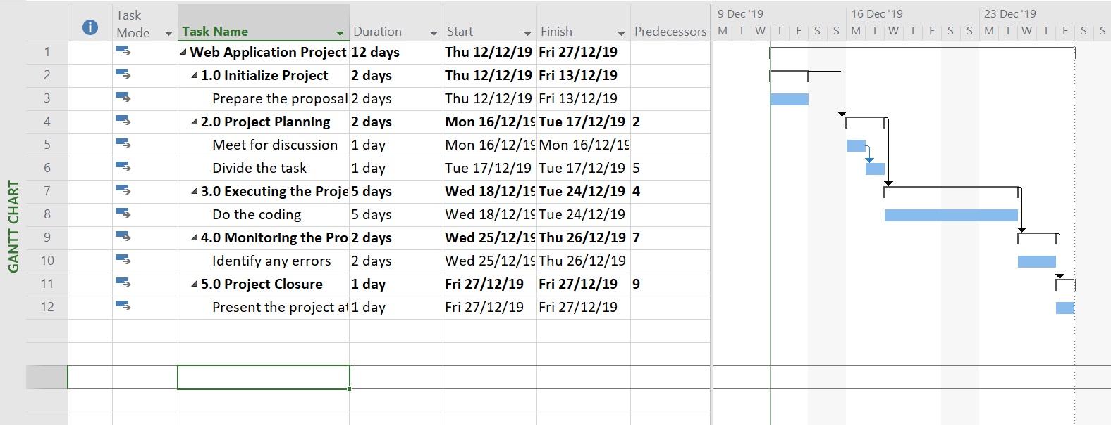

**1.7 SIGNIFICANCE OF THE PROJECT**

The benefits of this project are to ease the administrator to register cat’s information details, record cat’s health, update cat’s health, and register adopter’s information details. Administrator can also find it easy to do all this task anytime and anywhere. Besides, we also can reduce unnecessary paperwork in maintaining cat’s information. It also provides easy, accurate, unambiguous and faster data access.

**1.8 SUMMARY**

This project is basically about the system that manage the rescue shelter to help the stray cats in IIUM. One of the main purpose is I want to build a system that can manage the rescue shelter for IIUM stray cats with the objectives to rescue, treat (if needed), neutered and find adopters for the cats. This system is supervised by the administrators which all the details of the cat will be registered and keep ongoing updated. The administrator can access cat management information system website online through phone and laptop and register the information needed and manage cat data.

# 1.9 REFERENCES

1) Liang, Y. D. (2015). Introduction to Java programming. Boston: Pearson.

2) MVC in JSP. Retrieved 12 December 2019 from

https://www.javatpoint.com/MVC-in-jsp3) Pet Finder. Retrieved 12 December 2019 from

https://www.petfinder.my/listings.php?page=6&sorttype=2&sortage=&sortadopt=0&sortfield=&sortbreed1=&sortbreed2=&sortstate=41326&sortquery=